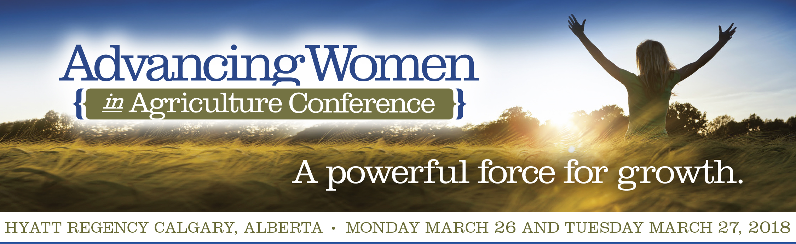

STUDENT APPLICATION
to ATTEND AWC WEST 2018
DEADLINE FOR COMPLETE APPLICATIONS IS February 16, 2018

STEP 1 – Personal Details:
First Name: Middle initial:
Last Name:

Permanent Address:
Address:
City: Prov/State:
Country: Postal Code / Zip:
Phone: Cell Phone:
Email:

STEP 2 – Education Information:
Name of University/College:
Degree/Major:
Current Status/Year of Study:
Degree/Major:
Department head contact info:
Name:
Title:
Email:
Address:
Phone:

Step 3: Please answer the following questions and they will be posted on the AWC website and in the conference printed program.
Please describe your education and previous work experience.
________________________________________________________________________________________
________________________________________________________________________________________
________________________________________________________________________________________
________________________________________________________________________________________
________________________________________________________________________________________
________________________________________________________________________________________
________________________________________________________________________________________
________________________________________________________________________________________

Please explain why you are interested in attending the Advancing Women Conference and how you would expect the program to benefit your career objective.
________________________________________________________________________________________
________________________________________________________________________________________
________________________________________________________________________________________
________________________________________________________________________________________
________________________________________________________________________________________
________________________________________________________________________________________
________________________________________________________________________________________
________________________________________________________________________________________

Student Signature Date

STEP 4 – Application Checklist: make sure you have provided us the following with your application.
☐ Completed application form
☐ Profile – a brief overview of your background, area of studies and career plans.
☐ A video (3-minute maximum, posted to YouTube and we ask that you provide us with a link to the video)
that describes your background, area of studies, career plans and why you think attending the Advancing Women Conference will be of benefit to your career objective.

☐ Head and shoulders, color photo suitable for publishing – please provide digital, in jpeg or pdf files. The photo must be at least 250 K in size.

Please return all required materials to: Email: beth@irismeck.com

For further information, please contact us at (403)686-8407

PLEASE NOTE: The sponsorship covers your registration fee to attend the AWC WEST 2018 conference (including Monday morning workshops, afternoon plenary, reception, and banquet and networking coffee breaks, and on Tuesday breakfast, lunch, coffee breaks and all day conference session) and two nights’ accommodations, Sunday March 25 and Monday March 26, 2018 at the Calgary Hyatt Regency. It is mandatory that you attend a morning workshop and the entire conference or your sponsorship may be revoked and you will have to pay for expenses incurred.
You will be responsible for all travel and additional expenses incurred.

Terms of agreement: The conference will be recorded and photographed at the discretion of Iris Meck Communications Inc. Your application, registration and attendance at the event signifies your permission to utilize your image and/or likeness, name, university and city/province, and words spoken or written about the Advancing Women Conference in print, AWC Website, AWC YouTube and Instagram and online reporting prior to or post of the event for perpetuity. No limitations or restrictions apply.

